

|  |  |
| --- | --- |
| **Course Number and Name:**  ME 747 Experimental Measurement and Design | |
| **Semester and Year:**  Fall 2017 | **Name of Lab Instructor:**  Alireza Ebadi |
| **Lab Section and Meeting Time:**  4B Thursday | **Report Type:**  External Group |
| **Title of Experiment:**  Static Test Fire thrust analysis | |
| **Date Experiment Performed:**  12/6/17 | **Date Report Submitted:**  12/13/17 |
| **Names of Group Members:**  Kevin Bucher  Reilly Webb  Nick Clegg | **Grader's Comments:** |
| **Grade:** |



Alireza Ebadi  
33 Academic Way  
Durham, NH, 03824

Dr. Ebadi,

The following document contains theoretical, experimental, and thermodynamic analysis of an Estes E9-6 Rocket engine.

The experimental setup consisted of a static test fire rig (STFR), which utilized a 100 lbf load cell attached to a 1” diameter fixture. The load cell output is connected to an amplifier and oscilloscope to obtain a thrust curve for the burn. This assembly was designed to be a prototype, as the full-sized rig will be expected to handle larger engines with maximum forces in the vicinity of 150 lbf and a max diameter of 1 ¼”.

Various analyses were then performed using the obtained thrust curve. System parameters were determined from the experimental data, which were used to model the decaying thrust as a first order system. The time constant of the system was found to be 0.07 s. Maximum measured thrust and impulse were found to be 25.7 N and 30.5 N-s, respectively. Additionally, engine efficiencies were estimated using a thermodynamic analysis. Kinetic energy and efficiency was found for assuming constant velocity of the air leaving the engine and for variable velocity. The heat transferred from the engine to the environment was calculated to be 103 kJ. The best estimation of kinetic energy was 28.8 kJ, which resulted in an engine efficiency of 28.1%.

Analysis proved that the engine’s thrust response can be partially approximated by a 1st order system and that maximum thrust and impulse could accurately be measured. Steps can now be taken towards the manufacturing and testing of the final STFR design. Treating the engine as a thermal system, the efficiency was estimated. Many simplifying assumptions were necessary, however, that affected the accuracy of results.

Best Regards,

Reilly Webb

Nick Clegg

Kevin Bucher

# TABLE OF CONTENTS

Contents

TABLE OF CONTENTS 3

LIST OF TABLES 4

LIST OF FIGURES 4

OBJECTIVES 5

EXECUTIVE SUMMARY 6

THEORY AND EXPERIMENTAL METHODS 7

RESULTS AND DISCUSSION 11

CONCLUSIONS 17

REFERENCES 19

APPENDICES 20

A. Data Tables 20

B. Sample Calculations 21

C. Equipment List 22

D. Raw Data Sheets 22

PEER EFFORT 23

# LIST OF TABLES

*Table 1: Estes E9-6 parameter comparisons* 6

*Table 2: Thermal System Parameters* 6

*Table 3: 1st Order System Results* 12

*Table 4: Estes Specification Chart* 19

*Table 5: 1st Order System Full Results* 20

*Table 6: Thermal System Calculations* 20

# LIST OF FIGURES

*Figure 1: Static Test Fire Prototype* 7

*Figure 2: Experimental setup* 8

*Figure 3: Engine before ignition* 8

*Figure 4: Engine after burn* 8

*Figure 5: Load cell calibration* 11

*Figure 6: Experimental thrust curve for an E9-6 rocket engine* 12

*Figure 7: 1st order model of max thrust decaying to steady state* 13

*Figure 8: Manufacturer provided thrust curve* 14

*Figure 9: 1st order response comparison in time domain* 15

# OBJECTIVES

The objective of this project is understand the response of thrust data and approximate a theoretical thrust curve. This will be done by obtaining an experimental thrust curve through the use of a static test fire prototype using a SM-100 load cell (100 lbf). This data will be used to calculate an experimental impulse value and compare to an expected value. The data will be approximated as a first or second order system and system parameters will be obtained and used to find a theoretical thrust curve. Lastly, the efficiency of the heat to work conversion of the black powder engine will be determined through thermodynamic analysis. Approximations will be done assuming constant air velocity and again assuming varying air velocity. This work is important as it will give the team a deeper understanding of the response of a rocket engine and the relationships between specific parameters.

# EXECUTIVE SUMMARY

A portion of the experimental data recorded by the load cell accurately reflected a theoretical 1st order response. Comparisons were made in both the time domain and frequency domain. Table 1 displays important system parameters for the E9-6 engine.

*Table 1: Estes E9-6 parameter comparisons*

|  |  |  |
| --- | --- | --- |
| **Parameter (units)** | **Measured** | **Expected** |
| Time Constant (s) | 0.07 | -- |
| Maximum Thrust (N) | 25.7 | 25 |
| Maximum Impulse (N-s) | 30.5 | 30 |

The time constant of the engine response was found to be 0.07 s. The measured thrust and impulse responses were compared to the expected Estes E9-6 engine specifications giving by the manufacturer and found to be very accurate [1]. Similarities between experimental and theoretical thrust curves gave reassurance for the accuracy and effectiveness of the STFR.

Table 2 displays major thermodynamic results for both constant velocity and time-variable velocity analyses.

*Table 2: Thermal System Parameters*

|  |  |  |
| --- | --- | --- |
| **Parameter (units)** | **Constant Velocity Method** | **Variable Velocity Method** |
| Total Heat (kJ) | 102.6 | 102.6 |
| Kinetic Energy (kJ) | 26.3 | 28.8 |
| Efficiency (%) | 25.6 | 28.1 |

The best estimate for efficiency, defined as the ratio of kinetic energy to total heat, was calculated to be 28.1%. This efficiency is more accurate as it considers time dependent air velocity. With both thermodynamic analyses came many simplifying assumptions, resulting in potential error within the results. For example, to find the variable velocity of the air leaving the engine the flow was assumed to be incompressible. In practice, the air flow is compressible. Regardless, if engine efficiency could be increased, a potentially significant amount of thrust could be gained for the E9-6 engine.

# THEORY AND EXPERIMENTAL METHODS

The sole purpose of a static test fire rig is too obtain thrust and impulse. A STFR setup typically consists of an engine housing, a force sensor and any supports deemed necessary. The setup used for experimentation can be seen in Figure 1.

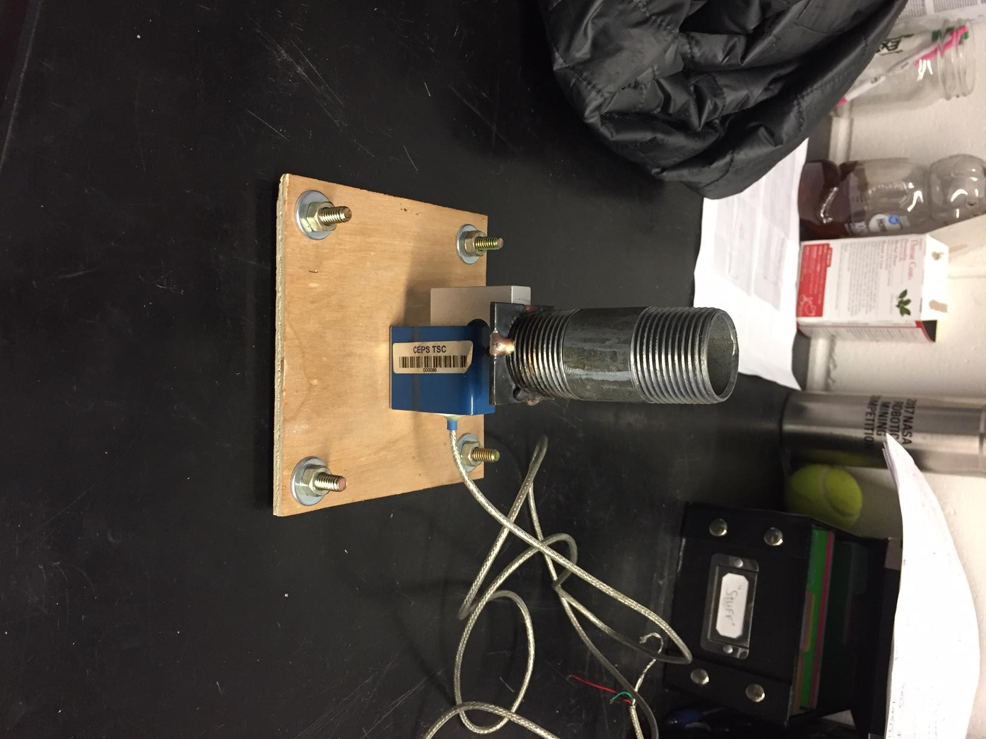

*Figure 1: Static Test Fire Prototype*

The fixture consists of a 1” inner diameter steel tube welded to a steel base plate. The base plate is threaded into the SM-100 load cell, which is all bolted into a wood base. The screws on the side are used for the reason of keeping the wood elevated above the screw bolt from the load cell, adding stability. The load cell is wired to an AD620-03 amplifier which is then connected to the oscilloscope. A power supply of -15 V to +15 V is connected to the amplifier. The software Virtual Bench was utilized to obtain data. The static test fire was placed outside in the Kingsbury courtyard with the electronics close by to obtain data. The engine was ignited by sending current through a high resistance filament.

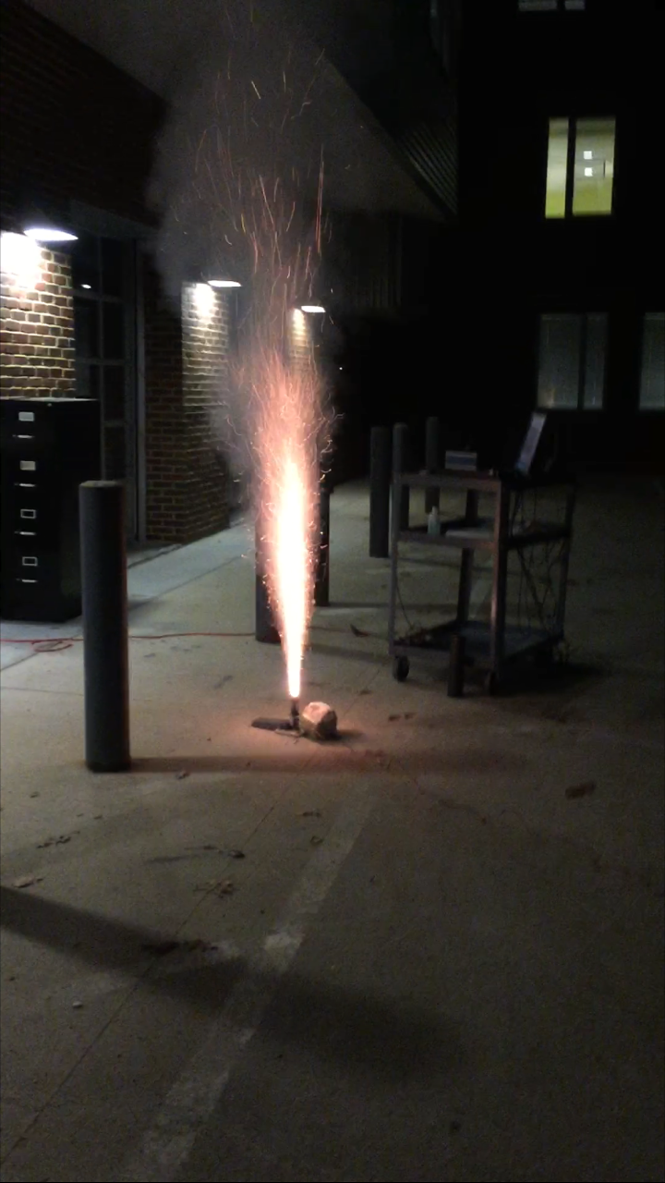

*Figure 2: Experimental setup*

In Figure 2 the engine can be seen releasing exhaust gases upward, applying thrust downward onto the load cell. The engine is solid propellant and burns for 3.1 seconds at varying thrust loads. There is a delay charge after the burn used for ejection of multistage rockets; this data was not recorded. Rocks were used to keep the rig in place while burning. The assumption is that the force was 100% in the downward direction with no horizontal effects coming into play. This experiment was performed twice, as the trigger settings were adjusted to obtain better data.

For the second experiment, engine weight was measured before and after ignition as seen in Figure 3 and Figure 4.

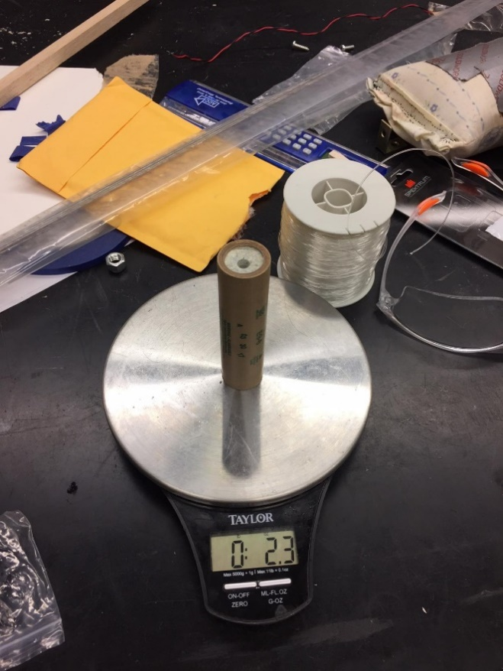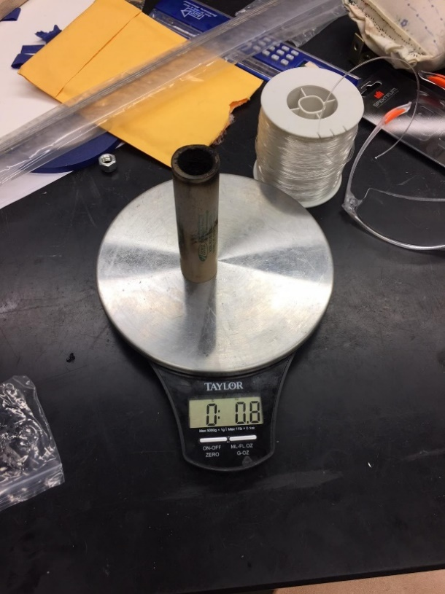

*Figure 3: Engine before ignition*

*Figure 4: Engine after burn*

The engine has a starting mass of 2.3 oz. and a final mass of .8 oz. and assuming constant mass flow rate we can use Equation 1 to find mass flow rate.

$\dot{m}= \frac{initial mass-final mass}{t}$*Equation 1*

After obtaining Voltage vs. Time data, the load cell needed to be calibrated. This was done by applying free weights to the load cell and taking a line of best fit and using the slope of the line to obtain a sensitivity in the form of Equation 2.

$K=\frac{F}{e_{o}}$*Equation 2*

After converting the output voltage to force, the experimental thrust curve was compared to the expected thrust curve from an E9-6 Estes engine. The impulse of the engine was found by integrating the area under the thrust curve. This value was then compared to the expected value. Obtaining impulse from our engine is extremely important as that is the main parameter we are limited by in competition.

First, we will analyze the response in the frequency domain by assuming the mass flow rate is constant we will attempt to approximate part of the thrust curve as a first order system using Equation 3.

$\frac{F(s)}{\dot{m}(s)}=\frac{K}{τs+1}$*Equation 3*

$τ$ is found by using the 0.632 method and the gain, K, is found by using Equation 4.

$K=\frac{Thrust}{Mass flow rate}$*Equation 4*

The thrust is the value from the max thrust to the steady state thrust, and mass flow rate is found using Equation 1. The transfer function is plotted over the experimental response and they are compared.

Next, we analyze the thrust is the time domain using a standard first order differential equation seen in Equation 5.

$\frac{dT}{dt}+CT=0$*Equation 5*

Solving Equation 5 for thrust, T, as a function of time, t, we arrive at the following solution in Equation 6:

$T=T_{ss}(1-e^{\frac{-t}{τ}})$*Equation 6*

Using Equation 6 we can plot thrust as a function of time using the system time constant, $τ$, and the steady state thrust value. This is also plotted over the experimental data to compare results.

In the interest of further analyzing the response, the efficiency of the engine was investigated. To do this, the 1st law of thermodynamics was simplified as follows:

$\frac{dE}{dt}=\dot{Q}-\dot{W}+{\dot{m}}_{in}\left(h_{in}+\frac{{v_{in}}^{2}}{2}+gz_{in}\right)-{\dot{m}}_{out}\left(h_{out}+\frac{{v_{out}}^{2}}{2}+gz_{out}\right)$*Equation 7*

$Q_{total}={\dot{q}}_{hv}m$*Equation 8*

From selecting the black powder as the system and greatly simplifying Equation 7, the total heat expended by the system was found to equal the heating value of black powder multiplied by the total mass of the propellant.

The thrust of the system can be modelled as such:

$F=\dot{m}v$*Equation 9*

Here, $F$ is the measured thrust from the engine response, $\dot{m}$ is the mass flow rate of the air leaving the nozzle, and $v$ is the velocity of the air leaving the nozzle. The efficiency was calculated with two methods. The first was to assume constant velocity of the air and estimate the velocity from the height of the flame from the exhaust of the engine. Then, by using Equation 9, the varying mass flow rate of the air was calculated. Now knowing the mass flow rate and velocity, the following relationship, in Equation 10, was used to calculate the total kinetic energy produced by the engine.

$KE=\int{\frac{1}{2}}\dot{m}v^{2}dt$*Equation 10*

By computing the ratio of kinetic energy to total heat, an estimation of the engine’s efficiency can be made.

To take a look at the accuracy of this method, the kinetic energy was also calculated with varying velocity with respect to time; a method that was expected to provide a much more accurate relationship between total heat and total kinetic energy. The following derivation shows how velocity found as a function of time.

$$F=\dot{m}v$$

$$\dot{m}=\frac{dm}{dt}=\frac{dρV}{dt}=\frac{dρA∆x}{dt}=ρA\frac{dx}{dt}=ρAv$$

$$F=\left(ρAv\right)v=ρAv^{2}$$

$v=\sqrt{\frac{F}{ρA}}$*Equation 11*

$F$ is the force recorded during experimentation, which varies as a function of time. Density was assumed to be the density of air at 100 kPa and a temperature of 1371 $℃$. The air is at atmospheric pressure when it leaves the nozzle and the temperature of the air leaving an E9-6 Estes engine is approximately 2500 $℉$ (1371 $℃$.) The area was found by measuring the diameter of the engine nozzle using Vernier calipers. Once velocity was calculated as a function of time, it was substituted into the Equation 12 to solve for the kinetic energy.

$KE=\int{\frac{1}{2}ρAv^{3}dt}$*Equation 12*

The kinetic energy and total heat could again be used to describe engine efficiency. The two efficiencies found using each method can be compared to draw conclusions as to how effective the system is at converting heat to useful work, which ultimately propels the rocket into the air.

# 

# RESULTS AND DISCUSSION

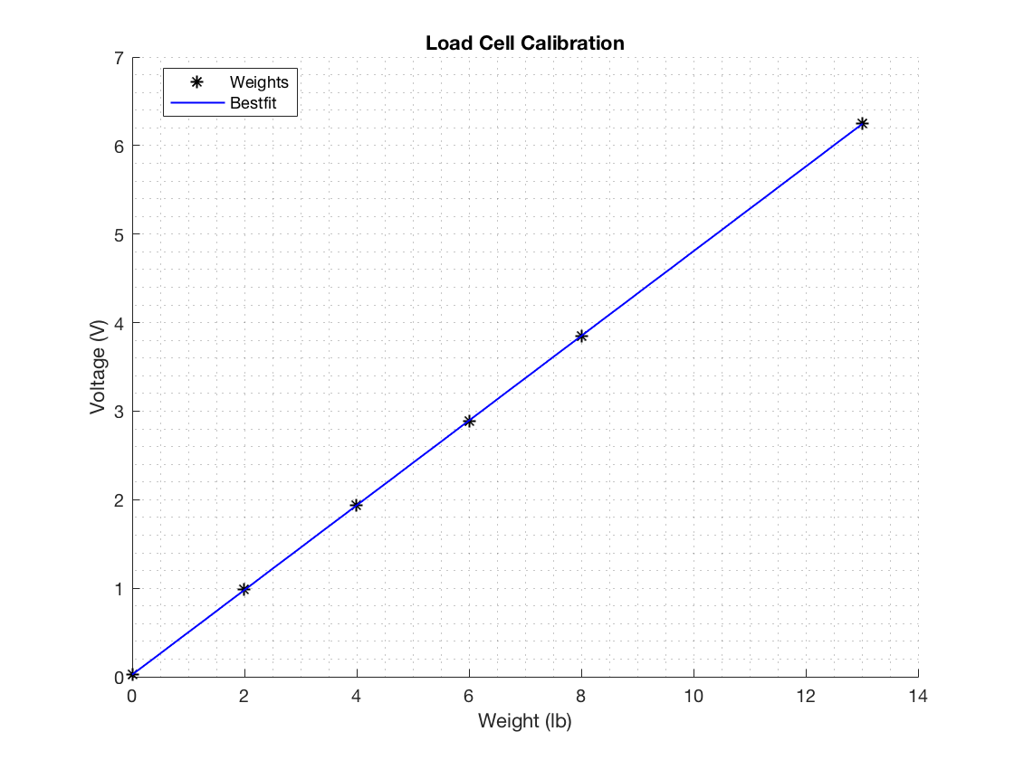

*Figure 5: Load cell calibration*

The load cell calibration resulted in a linear fit as seen in Figure 5.The sensitivity of the load cell was found to be 0.48 V/lb. This sensitivity was used to convert our raw data from voltage to thrust, shown below in Figure 6.

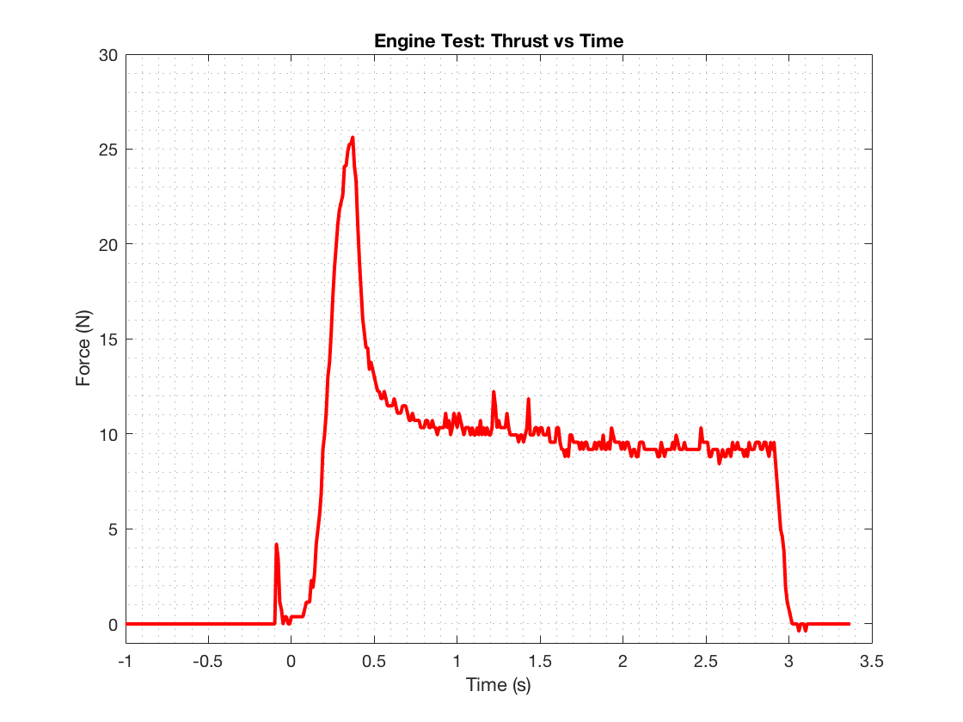

*Figure 6: Experimental thrust curve for an E9-6 rocket engine*

The initial ignition is shown by the small peak before t=0, then the max thrust of 25.7 N is achieved in less than half a second. The thrust then decays to a near steady state thrust of about 9.57 N, and the burn is finished within 3 seconds. This particular engine has a 6 second delay for the ejection charge. If data was captured for a longer period of time, an additional spike in the response would be seen at t=6 seconds. For the analysis performed, however, this end portion of the response was not of interest or relevance.

The engine that will be tested and used in the final rocket design is nearly 10 times as powerful as the Estes E9-6, and will reach peak thrust of about 300 N.

The section of the thrust curve that decays to steady state from the maximum peak was modeled as a 1st order system with the parameters displayed in Table 3.

*Table 3: 1st Order System Results*

|  |  |  |
| --- | --- | --- |
| **Parameter (units)** | **Measured** | **Expected** |
| Sensitivity (V/lb) | 0.48 | -- |
| Gain | 1123 | -- |
| Time Constant (s) | 0.07 | -- |
| Maximum Thrust (N) | 25.7 | 25 |
| Maximum Impulse (N-s) | 30.5 | 30 |

This first order response in the frequency domain is defined as Equation 3. Where the system parameters were found to be $τ=.07 s$ and a gain of $K=1123$. The system time constant was calculated using the 0.632 method and the gain was found from diving the system output by the system input. The response was then shifted to match that of the experimental data. The input of the system is the mass flow rate of the engine propellant. The Estes E9-6 uses black powder. The mass flow rate was calculated to be 0.014 kg/s. Since there is no accurate way to measure the amount of mass that was burned during the initial spike in thrust shown in Figure 6, the total mass of the propellant was used as the effective mass. A good estimation was found, although there is some degree of error present. The duration of the 1st order response was 2.52 s.

The theoretical 1st order system response is shown in Figure 7, plotted alongside the experimental response.

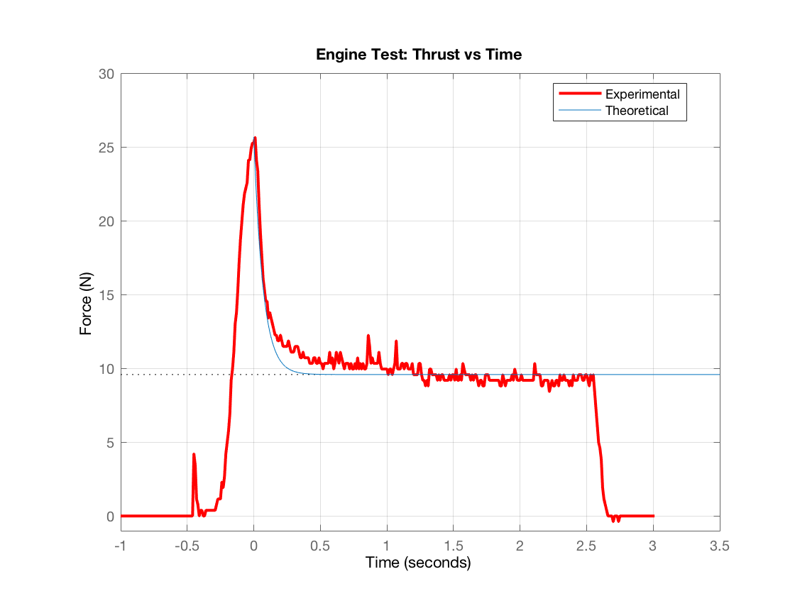

*Figure 7: 1st order model of max thrust decaying to steady state*

The theoretical fit in Figure 7 dips below the experimental curve before it reaches steady state. This could be due to the assumption that the mass flow rate variable was assumed to be constant for this analysis. There is also a fair amount of noise in the experimental response that results in poorer fitment to the theoretical curve. However, this theoretical thrust curve closely matches the thrust curve that is provided by the manufacturer in Figure 8.

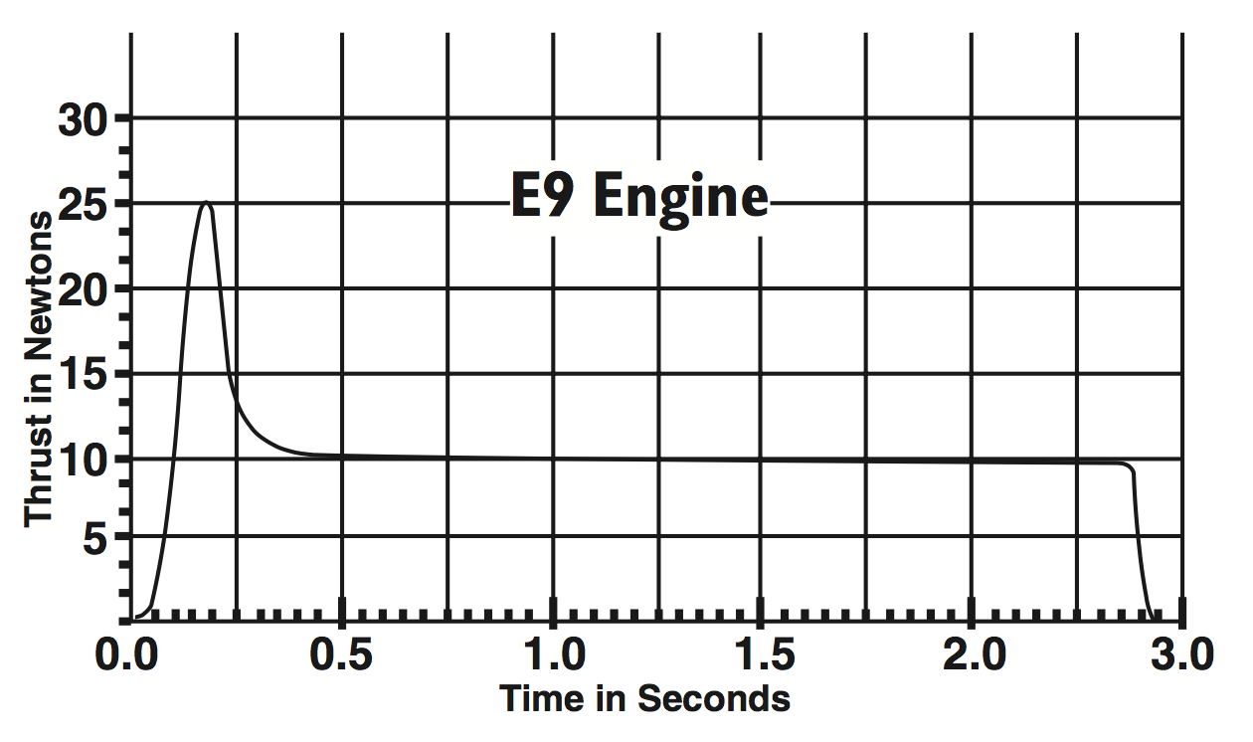

*Figure 8: Manufacturer provided thrust curve*

Figure 8 shows that the expected maximum thrust is 25 N and a steady state thrust of 10 N, which corresponds to a 2.8% and 4.3% difference respectively from the experimental results. The total burn time of less than 3.0 seconds is about the same for each thrust curve. The STFR performed effectively and the measured response was very similar to the expected engine response.

Both of the thrust curves in Figure 7 and Figure 8 can be integrated to find the total impulse of the engine. The experimental total impulse was found to be 30.5 N-s and the impulse provided by the manufacturer was 30 N-s. This is a difference of about 1.67%. Again, the differences in magnitude are minor, and the measurement setup could confidently be used to accurately record thrust responses from various other engine types. The total combined impulse of the rocket engines used for the SEDS competition cannot surpass 640 N-s. Performing this analysis with a more sophisticated STFR design and the larger engines will be crucial to ensure that the maximum allowable impulse is not exceeded.

In addition to comparisons to a 1st order system response the frequency domain, the experimental data was also compared to a 1st order system response using the time domain. Equation 6 is the solution to the differential equation, and Figure 9, below, displays the relationship.

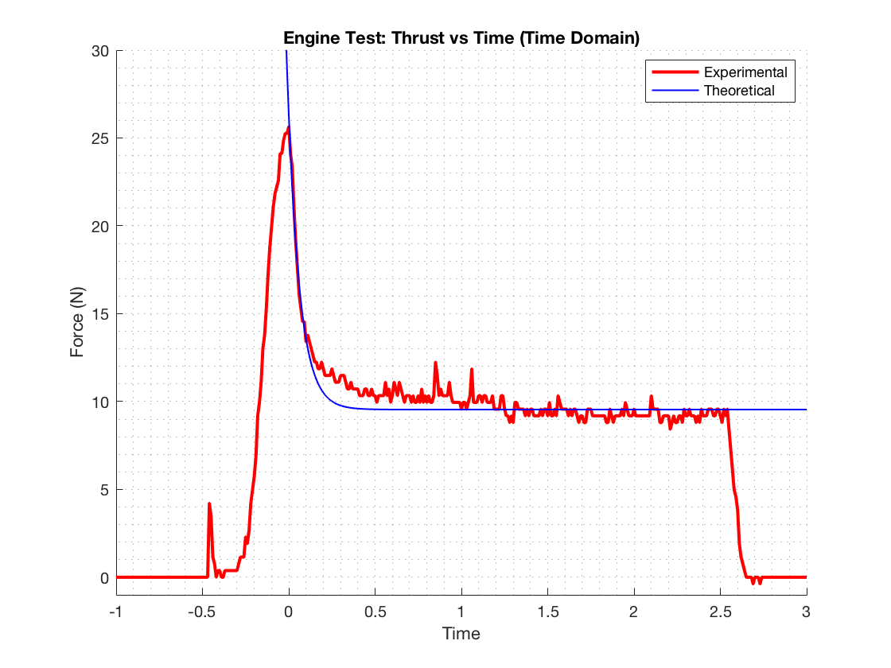

*Figure 9: 1st order response comparison in time domain*

To use this 1st order system approximation, the time constant and steady-state thrust were utilized in addition to the recorded time array. This allowed for a thrust calculation as a function of time. The calculation did not take into account a varying mass flow rate with respect to time.

Both 1st order system comparisons, in Figures 7 and 9, offered reassurance that the E9-6 engine thrust response was captured accurately and effectively by the STFR setup.

To further investigate the thrust response from the engine, a thermodynamic analysis was performed to compare the total heat production of the system to the kinetic energy of the air leaving the engine and comment on the efficiency of the engine. The total heat produced by the black powder propellant was calculated, using Equation 8, to be 103 kJ. Black powder has a thermodynamic heating value of 2866 kJ/kg. The total mass of the propellant was found by weighing the engine before and after the experiment and was recorded to be 0.043 kg. One way to define the efficiency of the E9-6 engine is to estimate it to be the ratio of the total kinetic energy to the total produced heat. Firstly, the kinetic energy of the system will be calculated.

The system was first analyzed by using constant velocity. From viewing the recorded videos of the experiment, the air particles and exhaust gases leaving the engine were estimated to have travelled approximately 3.5 m in 0.25 s. This meant the average velocity of the air was assumed to be a constant 14 m/s, or 31.3 mph. Using the recorded thrust data and Equation 9, the mass flow rate of the air leaving the nozzle was calculated as a function of time. The rate of mass flow, as expected, was found to be directly proportional to the thrust of the engine. This means that the initial large spike in the data corresponded with air leaving the nozzle at the fastest rate. The maximum mass flow rate of the air was found to be 308 kg/s. Having found velocity and mass flow rate, the kinetic energy was calculated using Equation 10. For a constant velocity analysis, the total kinetic energy was found to be 26.3 kJ. This is approximately 25.6% of the total heat provided by the system.

One last analysis was performed assuming variable velocity with respect to time. This calculation was expected to be more accurate than assuming constant velocity. Equation 11 was used to calculate velocity using the measured thrust, density of the air leaving the nozzle, and nozzle area. The density of the exhaust air at 2500 $℉$ is 0.215 kg/ $m^{3}$. The diameter of the nozzle was measured to be 0.165 in (0.0042 m), giving a resulting area of 1.38e-05 $m^{2}$. With these known parameters, Equation 12 was used to calculate the kinetic energy of the system. For the consideration of time-variable velocity, the kinetic energy was calculated to be 28.8 kJ. The corresponding efficiency was found to be 28.1%. This value for efficiency is undoubtedly the more accurate calculation considering that velocity was assumed to be a function of time. It was surprising, however, that the efficiencies did not vary more drastically, given the simplifying assumption of a constant velocity. The variable velocity method increased the efficiency estimation by only 2.5%. 28.1% is believed to be a fair assessment of the Estes E9-6 engine efficiency, as a great deal of thermal loss is expected.

An engine efficiency of 28.1% means that just over one quarter of the heat done by the system is converted to useful work, or energy. Useful work, in this case, is the kinetic energy expended by the engine in the form of high velocity, high temperature air. This energy is what ultimately becomes responsible for providing the lift force that propels the engine and rocket upwards into the air. If the calculations performed are accurate within reason, then there may be a significant amount of thrust being lost that could potentially be recovered through achieving a higher engine efficiency.

# CONCLUSIONS

**Webb**:

The clear similarities between both the experimental and the manufacturer provided thrust curves allow us to confidently move forward in designing and constructing the fully sized static test fire rig. This is especially true with the total impulse estimate, as this will be one of the primary objectives of the final test rig. Having the ability to determine the total impulse of our engines will allow us to design future engines that approach the max impulse constraints for rocketry competitions.

Having an accurate estimation of the thrust curve will also allow us to predict the moment of booster decoupling as well as the release of recovery devices. This data can also be used in a dynamic analysis of the rocket’s powered flight.

Using the experimental thrust curve to predict efficiency will also be essential for designing our own rocket engines in the future. Overall this experiment has demonstrated the potential capabilities of the full-sized STFR and was an important step forward for SEDS club as a whole.

For future experimentation, we could analyze how varying engine parameters affects the output thrust curve. The diameter, length, and propellant type can be adjusted and a theoretical formula can be created based on the resulting thrust output to estimate dependencies.

**Bucher:**

The results of the thrust vs. time curve from the experimental and expected data is exactly the same. This confirms the accuracy of the static test fire design, proving that we are ready to move onto a larger scale model. Approximating part of the thrust curve as a first order response proved to be a somewhat accurate and reasonable assumption. The first ignition charge proved to be tough to model as there is no steady state output to analyze. It is important to note that while a first order approximation worked for this engine, it may not work for all engine models. This is because different engines burn at different rates with different mass flow rates, so it is not guaranteed to follow a first order response. Modeling the results of thrust from a systems dynamic approach is important because it will help approximate results without wasting resources.

A thermodynamic analysis helped explore the important relationship between mass flow and thrust. Thrust and mass flow rate proved to be proportional and helped find kinetic energy and in turn engine efficiency. 28% efficiency seems very inefficient for a rocket engine. This is most likely do to our experimental methods, such as measuring the speed of exhaust flow from a video. Very accurate results could have been produced if we measured the mass flow rate experimentally, however this was out of the scope of this project.

**Clegg:**

After experimentation and successfully recording the engine thrust response, the curve was found to partially act as a 1st order system. Both the frequency domain and time domain comparisons aligned properly with the experimental data. The expected thrust results provided by Estes are very similar to the data measured by the load cell. The accuracy and effectiveness of the acquired results and STFR setup assure the team that manufacturing can be started for the final design. The next, and hopefully final, iteration will be adjustable for varying engine lengths and diameters. Using the same experimental setup with a load cell of higher force measurement capabilities, the final engines being used for competition can be tested and analyzed.

The thermal analysis provided investigation and insight into the capabilities of an Estes E9-6: mainly the ability of the engine to convert heat to useful work. With an engine efficiency of 28.1%, there is great potential for an increase in the kinetic energy of the air leaving the nozzle. To improve results, the amount of simplifying assumptions made would need to be reduced. One way to more accurately predict velocity would be to analyze the air as a compressible flow. Mass flow rate could be estimated more effectively by knowing the inner dimensions of the engine, and knowing the exact temperature of the air leaving the nozzle would give a more accurate density value. Considerable experimentation and additional time would have been necessary to improve the experimental results for this analysis. Looking forward, further experiments can now be performed if the team wishes to obtain more accurate engine efficiencies.

# REFERENCES

[1] Estes Specification Chart

*Table 4: Estes Specification Chart*

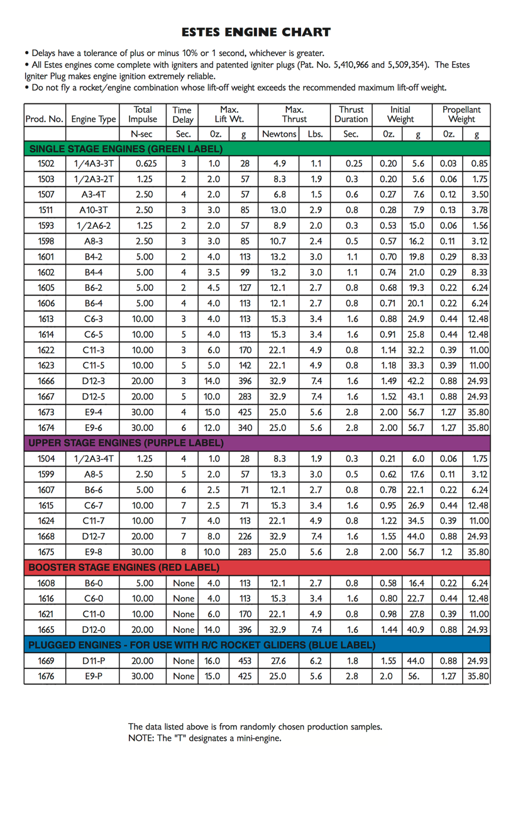

[2] “001674 - E9-6 Engines.” *Estes Rockets*, [www.estesrockets.com/rockets/engines/e-engines/001674-e9-6](http://www.estesrockets.com/rockets/engines/e-engines/001674-e9-6).

[3] “Air density calculator.” *Gribble*, <https://www.gribble.org/cycling/air_density.html>

# APPENDICES

## A. Data Tables

*Table 5: 1st Order System Full Results*

|  |  |  |
| --- | --- | --- |
| **Parameter (units)** | **Measured** | **Expected** |
| Sensitivity (V/lb) | 0.48 | -- |
| Gain | 1123 | -- |
| Time Constant (s) | 0.07 | -- |
| Maximum Thrust (N) | 25.7 | 25 |
| Maximum Impulse (N-s) | 30.5 | 30 |

*Table 6: Thermal System Calculations*

|  |  |  |
| --- | --- | --- |
| **Parameter (units)** | **Constant Velocity Method** | **Variable Velocity Method** |
| Black Powder Heating Value (kJ/kg) | 2866 | 2866 |
| Mass ( $kg)$ | 0.043 | 0.043 |
| Temperature ( $℉)$ | -- | 2500 |
| Density ( $kg/m^{3})$ | -- | 0.2149 |
| Nozzle Area ( $m^{2})$ | -- | 1.38e-05 |
| Total Heat (kJ) | 102.6 | 102.6 |
| Kinetic Energy (kJ) | 26.3 | 28.8 |
| Efficiency (%) | 25.6 | 28.1 |

## B. Sample Calculations

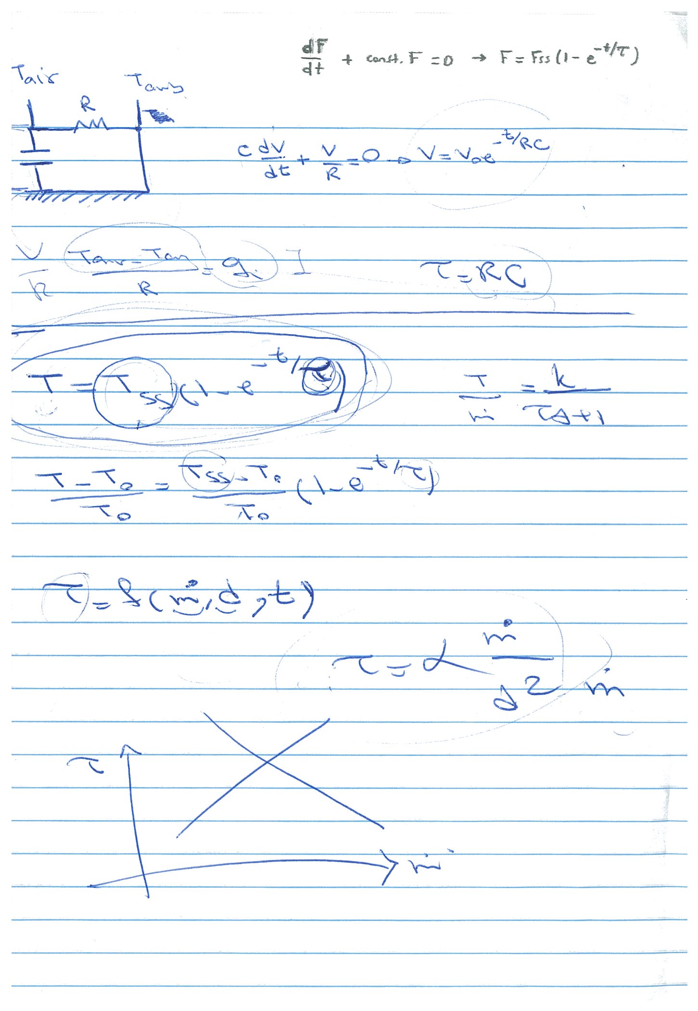

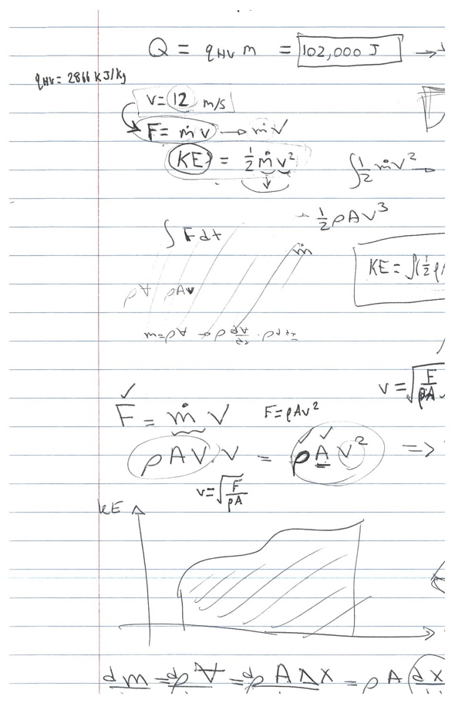

## 

## C. Equipment List

* E9-6 Estes black powder rocket engine
* Engine Ignition System
* 1” Diameter engine housing
* 5”x5” base board
* SM-100 load cell utilized (100lbf)
* AD620-03 amplifier
* +/-15 V mobile power supply.
* Oscilloscope
* Virtual Bench software
* Vernier calipers

## D. Raw Data Sheets

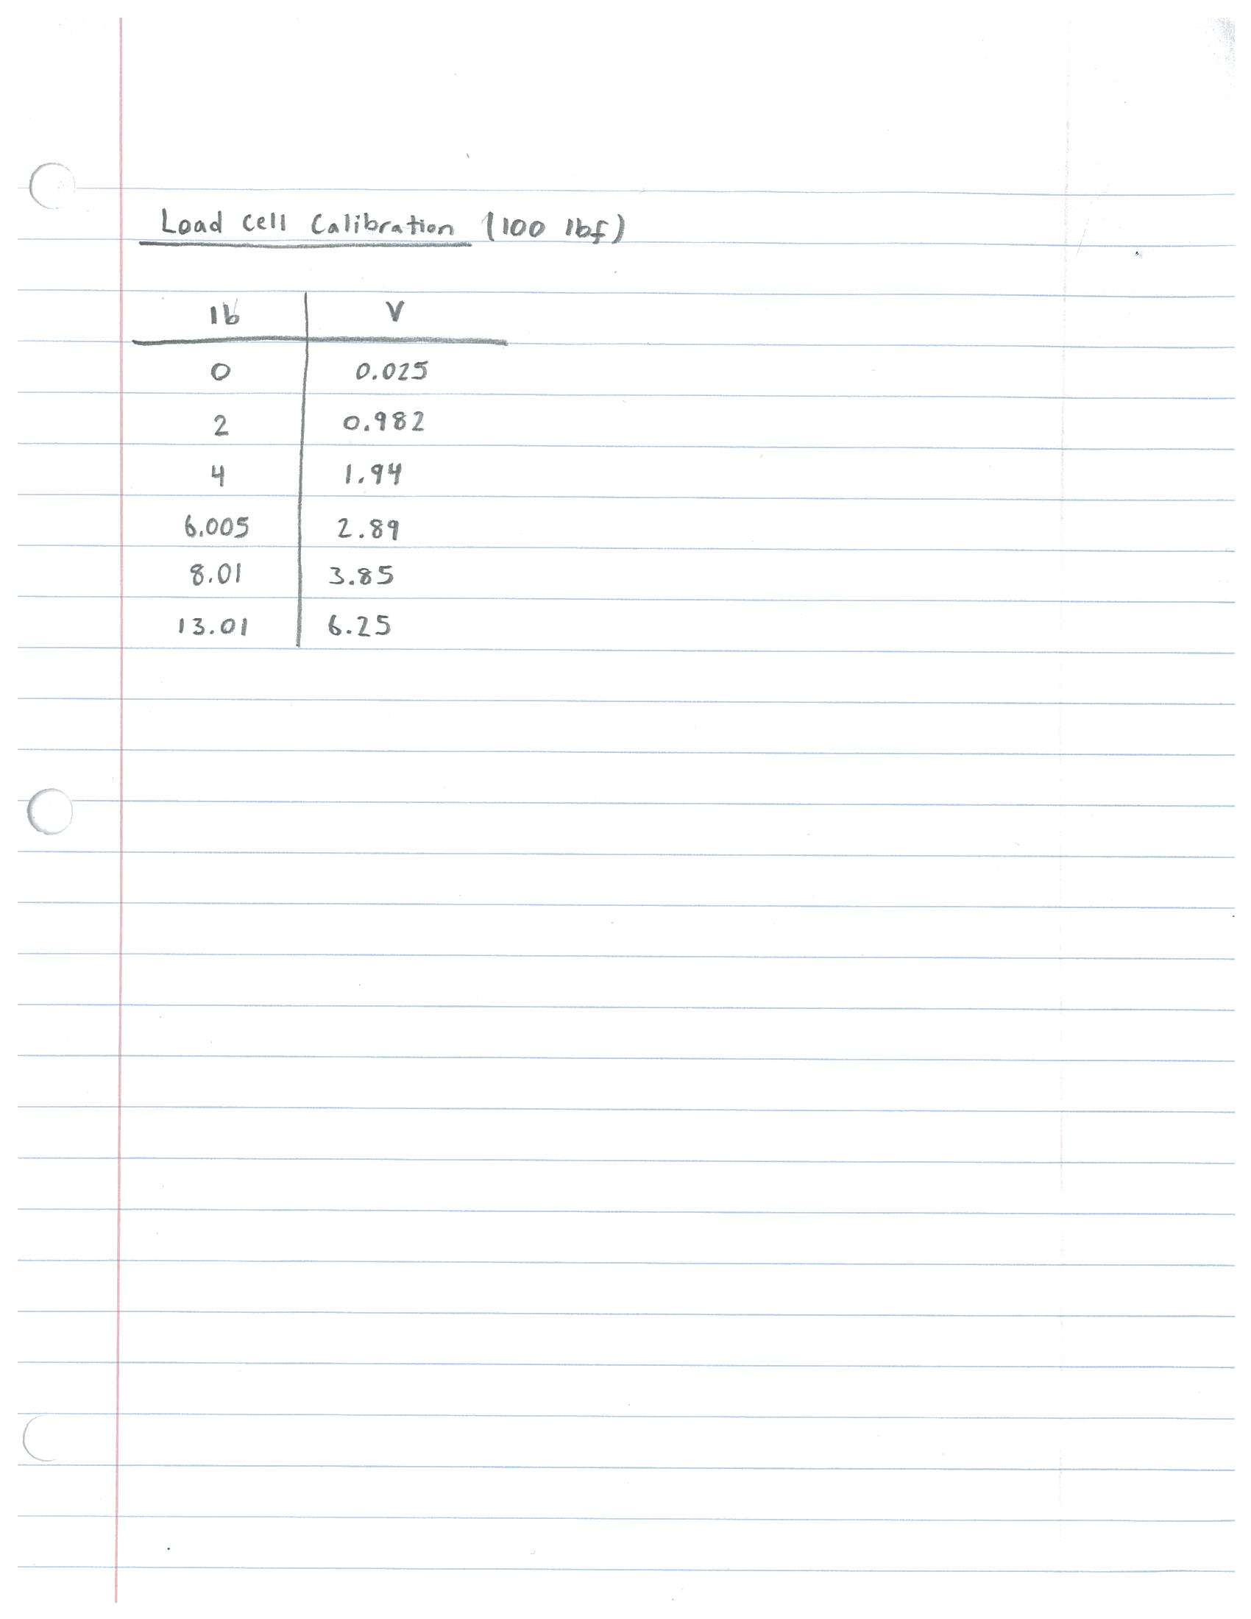

# PEER EFFORT

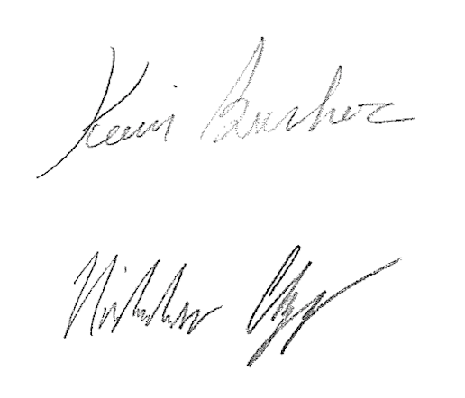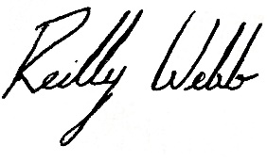

33.3%

33.3%

33.3%